**Cairo University Faculty of Computers and Artificial Intelligence**



**Software design specification document**

**2022**

**Project Team**

|  |  |  |
| --- | --- | --- |
| **ID** | **Name** | **Email** |
| 20200307 | عبدالله محمود زكريا |  |
| 20200302 | عبدالله صالح سيد |  |
| 20200274 | عبدالتواب محمد عبدالتواب |  |
| 20200406 | ماريو مدحت اديب |  |

**Contents**

Class diagram design 2

Class diagram Explanation 3

Sequence diagram design 3

Github repository link 4

# Subsystem decomposition diagram

# Class diagram design

# Class diagram Explanation

1- **Strategy Design pattern :** we use this pattern to make several behaviors from services **participant classes are**{ Services - InternetPayment – MobileRecharge – Landline – Donations – All Services Provider}

2- **Decorator Design pattern :** we use Decorator Design pattern allows us to dynamically add Discounts to Payment without affecting the behavior of other existing objects within the same class payment participant classes are{ Payment - PaymentBsl– PaymentController– CasheBsl – CreditCardBsl – WalletBsl – CashController -CreditCardController - Walletcontroller – Discount – SpecificDiscountBsl – OverallDiscountBsl - SpecificDiscountController }

3- **Observer design pattern :** we use it because we need to know when the customer ask for refund admin can see the request and accept this transaction or not **participant classes are**{ Admin - AdminBL –AdminController- Customer-CustomerBL- CustomerController }

4- **Singleton Design Pattern :** we use it on Overall Discount because we need one object from Overall Discount this created just one time to apply it in all Services **participant classes are**{ OverallDiscountBsl }

5- **Strategy Design pattern :**  we use this pattern to make several behaviors from Account **participant classes are**{ Account – AdminAccount – UserAccount }

# Sequence diagram design

1. 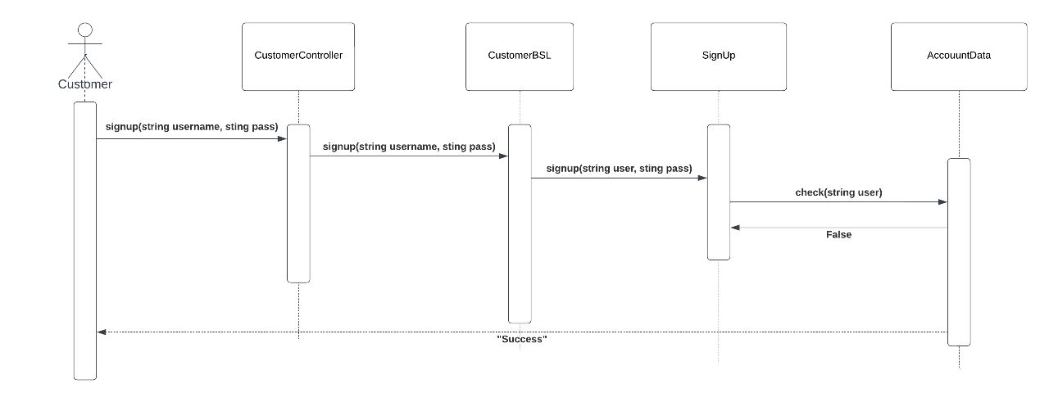**Customer Sign Up**

# 

1. **Diagram

   Description automatically generatedCustomer Sign In**
2. **Diagram

   Description automatically generatedCustomer Search**
3. **Diagram

   Description automatically generatedCreate Specific Discount**
4. 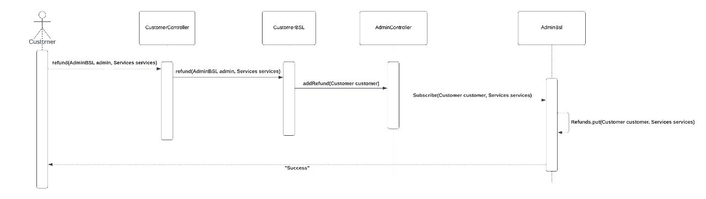Customer Ask for Refund
5. 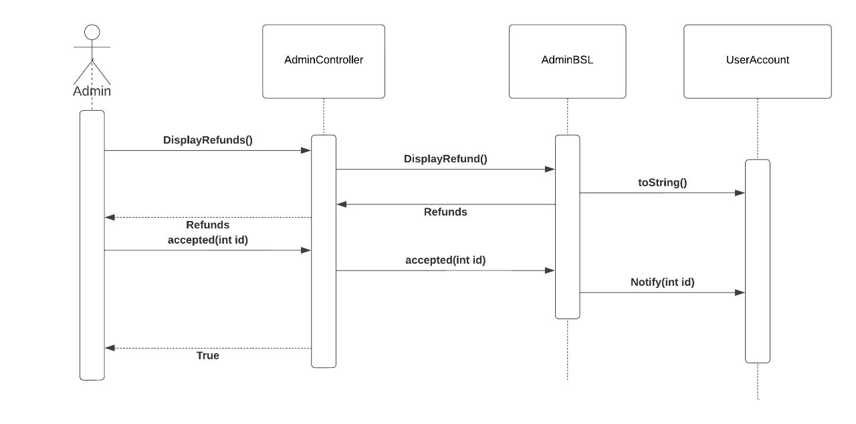Admin Display And Accepted Refund
6. 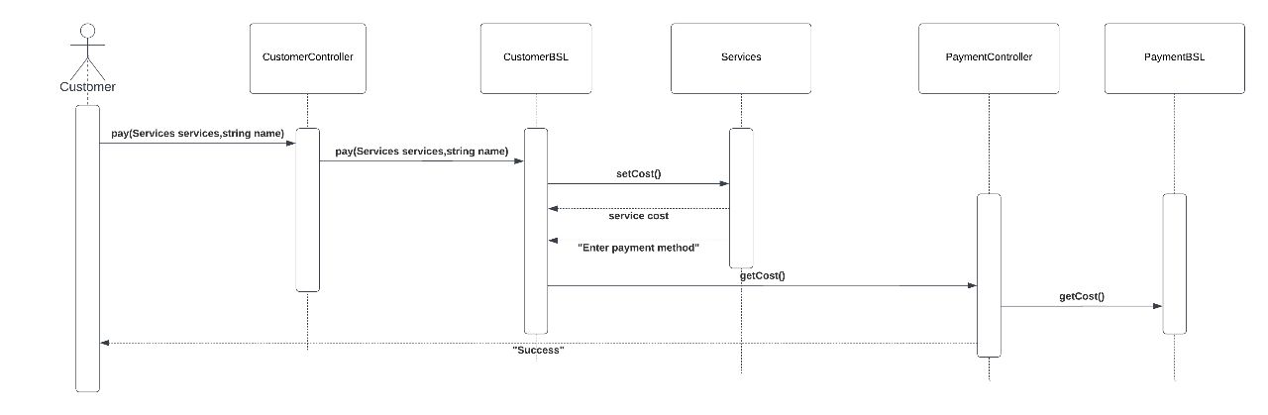Customer Pay
7. 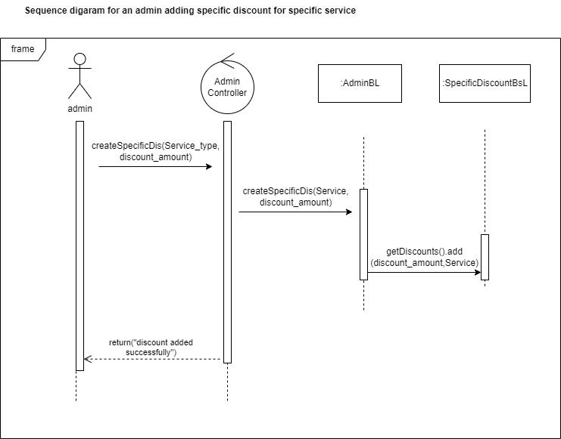Overall Discount

# Requirements Exposure as Web Service AP

**Part 1: Exposed Postman Collection**

**https://api.postman.com/collections/25092050-0d216dfe-9dbc-417c-bcc0-d5107a483df5?access_key=PMAT-01GNQMCQFYE4DV12849E3R3MXV**

**Part 2:**

**.**

|  |  |  |
| --- | --- | --- |
| Requirement |  | Exposed API |
| The user can pay for any service in the system. The system should prompt the user to the payment form when the user asks to pay for any service. |  | http://localhost:8080/search?name=mobile |
| The admin should be able to add any new service provider to the system. |  | http://localhost:8080/InsertServices |
| The user should be able to sign up to the system |  | http://localhost:8080/CustomerSignUp |
| The user should be able to signin to the system |  | http://localhost:8080/CustomerSignIn?name=abdalla |
| The user can ask for a refund for any complete transaction to any given service. |  | http://localhost:8080/addrefund |
| The admin should be able to list all refund requests. |  | http://localhost:8080/displayRefunds |
| The admin should be able to add discounts to the system create Specific Dis |  | http://localhost:8080/createSpecificDis?number=25 |
| Customer Add to wallet |  | http://localhost:8080/AddTowallet?id=0 |
| Admin Sign UP |  | http://localhost:8080/signUp |
| Admin Sign IN |  | http://localhost:8080/signIn |
| The admin should be able to add discounts to the system create Overall Dis |  | http://localhost:8080/createOverallDiscound?number=20 |
| Admin accept refunds |  | http://localhost:8080/accept?id=1 |
| Admin Display payment transaction |  | http://localhost:8080/PaymentTransaction |
| Admin Display Add to Wallet transaction |  | http://localhost:8080/AddtoWalletTransaction |
| The user can pay for any service in the system |  | <http://localhost:8080/pay?PaymentMethod=wallet&ID=0> |

# Github repository link

* **https://github.com/Abdallah531/Advanced-Software-Project**